Acute lymphoblastic leukemia in children
1-Normal hematopiosis:
Every day the human body produces billions of new white blood cells, red blood cells and platelets to replace blood cells lost, to normal cell turnover processes as well as to illness or trauma. A variety of homeosta-tic mechanisms allow blood cell production to respond quickly to stresses such as bleeding or infection and then return to normal levels when the stress is resolved (Akashi et al,. 2000)
The process of hematopoiesis involves a complex interplay between the intrinsic genetic processes of blood cells and their environment. This interplay determines whether Haematopoietic stem cells (HSCs) , progenitors and mature blood cells remain quiescent, proliferate, differentiate, self-renew or undergo apoptosis (Orkin and Zon , 2000).
Haematopoietic stem cells reside in bone marrow and have the unique ability to give rise to all of the different mature blood cell types and tissues. HSCs are self-renewing cells: when they differentiate, at least some of their daughter cells remain as HSCs, so the pool of stem cells is not depleted. The other daughters of HSCs (myeloid and lymphoid progenitor cells) can follow any of the other differentiation pathways that lead to the production of one or more specific types of blood cell, but cannot renew themselves (Morrison and Kimble, 2006).
The best characterized environmental regulators of hematopoiesis are cytokines. In general, cytokines function by engaging a specific receptor and activating a variety of signaling pathways. This includes activation of a tyrosine kinases such as focal adhesion kinase, pp60src, c-Abl, MAP kinases, jun Kinase (JNK) and protein kinase C (PKC) (Rane and Reddy, 2002).
Mediators of cell growth and differentiation such as c-src, phosphoinositides, protein kinase C and growth factor-mediated signaling pathways are also modulated by cytokines. Cytokines including interleukin-3 and GM-CSF induce cell proliferation, while other such as flt-3 ligand and kit ligand protect cells from apoptosis and sensitize them to the effects of growth promoting cytokines (Crooks et al; 2000)
Cytokines may also facilitate the interactions between stem cells and elements in the microenvironment including extracellular matrix (ECM) components (Kinashi and Springer, 1994).
Regulators of HSCs including transforming growth factor-beta (TGF-β) , tumor necrosis factor-alpha (TNF-α), Wnt and the notch ligand family modulate cell cycle activity and engraftment. TNF-α may act as inhibitor or activator depending on its concentration and other ongoing physiologic processes ( Lyman and Jacobsen , 1998).
Anumber of nutrients, trace elements, and vitamins (eg, zinc, selenium, copper, vitamins A, D, and E) are also critical to hematopoiesis. Retinoids and particularly retinoid antagonists play important roles in differentiation even at low concentrations (Taichman et al., 2000).
In addition to this the Rb family, the E2Fs, cyclins, SCL, Hox and other gene families appear to regulate proliferation and self renewal of early hematopoietic cells. The bcl family and others regulate apoptosis in hematopoietic cells. A variety of genes including the C/EBP, MyD, PaxB, and Ikaros appear to play critical roles in hematopoietic cell lineage commitment ( Georgopoulos , 2002).

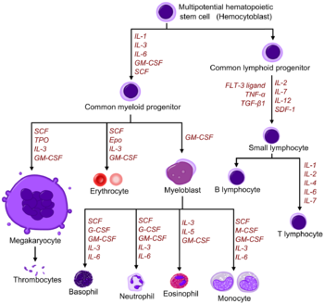
Figure (1): Hematopoietic Growth Factors (Hauke and Stefano, 2000).
An understanding of the principal mechanisms in hematopoiesis is important to the practice of oncology. Disorders of hematopoiesis underlie a number of hematologic malignancies and other disorders such as leukemia, aplastic anemia, lymphoma, myelodysplasia, myeloproliferative disorders and inborn errors of metabolism. Chemotherapy-induced cytopenia is one of the primary causes of morbidity and mortality in the treatment of cancer (Smith, 2003).
2-Acute lymphoblastic leukemia:
A-Incidence:
Acute leukemia is a malignant disorder in which hemopoietic blast cells constitute more than 30% of bone marrow cells. The primitive cells usually accumulate in the blood, infiltrate other tissues and cause bone marrow failure (Mehta and Hoffbrand, 2000).
Acute lymphoblastic leukemia (ALL) is the second most common acute leukemia in adults. The hallmark of ALL is chromosomal abnormalities and genetic alterations involved in differentiation and proliferation of lymphoid precursor cells. In adults, 75% of cases develop from precursors of the B-cell lineage, with the remainder of cases consisting of malignant T-cell precursors. ALL represents a devastating disease when it occurs in adults (Terwilliger and Abdul-Hay, 2017).
Acute lymphoblastic leukemia (ALL) is the most common cancer among children, which specifically involves the precursors of B and T cells. Within the United States, the incidence of ALL is estimated at 1.6 per 100 000 population. In 2016 alone, an estimated 6590 new cases were diagnosed, with over 1400 deaths due to ALL (American Cancer Society). The incidence of ALL follows a bimodal distribution, with the first peak occurring in childhood and a second peak occurring around the age of 50 ( Kantarjian and Jabbour, 2016).
B- Pathophysiology:
Studies in the pediatric population have identified genetic syndromes that predispose to a minority of cases of ALL, such as Down syndrome, Fanconi anemia, Bloom syndrome, ataxia telangiectasia and Nijmegen breakdown syndrome. Other predisposing factors include exposure to ionizing radiation, pesticides, certain solvents or viruses such as Epstein-Barr Virus and Human Immunodeficiency Virus. However, in the majority of cases, it appears as a de novo malignancy in previously healthy individuals (Shah et al. 2013).

C- Classification:
In 1997, the World Health Organization proposed a composite classification in attempt to account for morphology and cytogenetic profile of the leukemic blasts and identified three types of ALL: B lymphoblastic, T lymphoblastic and Burkitt-cell Leukemia (Harris et al., 1997).
In 2008, Burkitt-cell Leukemia was eliminated as it is no longer seen as a separate entity from Burkitt Lymphoma, and B-lymphoblastic leukemia was divided into two subtypes: B-ALL with recurrent genetic abnormalities and B-ALL not otherwise specified (Vardiman et al., 2009).
1- B-ALL with recurrent genetic abnormalities:
In adults, B-cell ALL accounts for ~ 75% of cases while T-cell ALL comprises the remaining cases. Two new provisional entities were added to the list of recurrent genetic abnormalities , hypodiploid and low hypodiploid with TP53 mutations (Arber et al., 2016).
Chromosomal aberrations are the hallmark of ALL, but are not sufficient to generate leukemia. Characteristic translocations include t(12;21) [ETV6-RUNX1], t(1;19) [TCF3-PBX1], t(9;22) [BCR-ABL1] Ph-positive ALL. More recently, a variant with a similar gene expression profile to (Philadelphia) Ph-positive ALL but without the BCR-ABL1 rearrangement has been identified ,this so-called Ph-like ALL (Mullighan et al., 2009).
Transcription factor 3 (E2A), early B-cell factor 1 (EBF1) , paired box 5 (PAX5) and kinase-activating mutations are seen in 90% of the Ph-like ALL. The most common of these include rearrangements involving ABL1, JAK2, PDGFRB, CRLF2 and EPOR (Holmfeldt et al., 2013).

1.1-B-cell lymphoblastic leukemia/lymphoma with t(9;22):
Approximately 20% to 30% of adult acute lymphoblastic leukemias (ALLs) and 5% of pediatric ALLs harbor the Philadelphia (Ph) chromosome t(9;22)(q34;q11.2). The fusion gene encodes a constitutively active BCR-ABL1 tyrosine kinase, which in turn promotes unregulated cell proliferation. This genetic alteration confers a poor prognosis, as defined by shorter remission duration and shorter survival and higher rates of resistance to standard chemotherapy (Moorman et al., 2007).
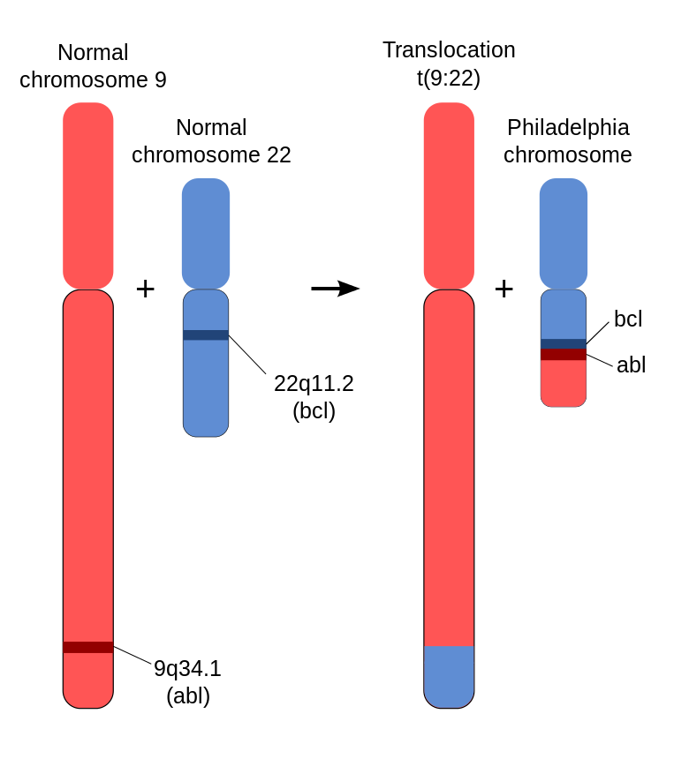
Figure (2): Philadelphia chromosome (Kurzrock et al., 2003).
1.2-B-cell lymphoblastic leukemia with hypodiploidy:
Recently described the genetic basis of another subset with poor outcomes, low-hypodiploid (32–39 chromosomes) ALL, alterations in p53 (91%), IKZF2 (53%) and RB1 (41%) were more common. In contrast, near-haploid (24–31 chromosomes) ALL, alterations in tyrosine kinase or Ras signaling was seen in 71% of cases and in IKAROS family zinc finger 3 (IKZF3) in 13% of cases. Both nearhaploid and low-hypodiploid exhibited activation of Ras- and PI3K-signaling pathways, suggesting that these pathways may be a target for therapy in aggressive hypodiploid ALL ( Holmfeldt et al., 2013).
1.3-B-cell lymphoblastic leukemia with Mixed-lineage leukemic gene (MLL) rearrangement:
Approximately 20% of all cases of ALL, including 80% of infant ALL and 10% of older children and adult ALL, exhibit MLL rearrangements. Both infants and adults with B-ALL associated with ( MLL) rearrangements have a poor prognosis. The t(4;11)(q21;q23) with an AF4 fusion partner is most common in infants. Patients with these tumors have a bimodal age distribution with high prevalence among infants younger than 1 year of age and an increasing incidence in later adulthood, while being relatively uncommon in older children (Gleissneret al., 2005).
1.4- B-cell lymphoblastic leukemia with t (5; 14):
In general, the presence of eosinophilia occurring with B-ALL raises several diagnostic possibilities, including but not limited to B-ALL associated with t(5;14) (q31;q32); lymphoid neoplasms with abnormalities of PDGFRA, PDGFRB, or FGFR1(von Bubnoff et al., 2006).
It is important to appropriately identify Ph+ cases and those with PDGFRA or PDGFRB abnormalities because these patients are often responsive to TKI therapy Thus, in patients with nonreactive eosinophilia, in addition to conventional cytogenetic analysis, fluorescence in situ hybridization (FISH) studies are recommended to identify FIP1L1-PDGFRA fusions and reciprocal translocations involving PDGFRA (4q12), PDGFRB (5q31-q33), FGFR1 (8p11-13) and juxtaposition of the promoter region of the interleukin-3 (IL-3) gene on chromosome 5 and the IGH gene on chromosome 14 (Loghavi et al., 2015).

2- B-cell lymphoblastic leukemia not otherwise specified:
By gene expression profiling, the lymphoblasts show high levels of FMS-related tyrosine kinase 3. The overall profile was similar to those seen in what is known as “cluster group 5,” which has been associated with a more favorable prognosis and remission 5 years after diagnosis (Harvey et al., 2010).
3- T-cell acute lymphoblastic leukemia (T-ALL):
T-cell acute lymphoblastic leukemia (T-ALL) represents approximately 12% to 15% of all newly diagnosed ALL cases in pediatric patients and is noteworthy for its unique clinical and biological features. Although historically, outcomes for T-ALL were inferior to those of B lymphoblastic leukemia (B-ALL), with recent advances in therapy, event-free survival (EFS) rates have been steadily improving and now exceed 85% in many contemporary clinical trials (Moricke et al.,2016).
Prognostic factors and risk classification differ in T-ALL compared with its B-lineage counterpart. Several of the clinical variables used to classify risk in patients with B-ALL, including age and presenting white blood cell count (WBC), are not independently prognostic in T-ALL. Many chromosomal translocations leading to aberrant transcription factor expression have been identified in T-ALL; however, the prognostic significance of these findings within the context of contemporary therapy is unclear, and blast cytogenetics features are also not presently used for risk stratification (Vora et al. 2013).

D-Symptoms:
Table (1): Presentations of acute leukaemia in children (Alvarez et al., 2007).
Underlying pathophysiology | Symptoms and signs
Systemic effects of cytokines | Malaise, fatigue, nausea and fever
Bone marrow infiltration
Anaemia | Pallor, lethargy, shortness of breath, dizziness, palpitations  And reduced exercise tolerance
Neutropenia | Fever, infection in general, recurrent infection and unusual infections, eg oral candida
Thrombocytopenia | Bruising, petechiae and epistaxis
Reticuloendothelial infiltration | Hepatosplenomegaly, lymphadenopathy, expiratory wheeze secondary to mediastinal mass (due to lymphadenopathy, thymic infiltration or expansion).
Other organ infiltration
CNS | Headaches ,vomiting, cranial nerve palsies and convulsions
Testes | Testicular enlargement
Leucostasis | Headache, stroke, shortness of breath and heart failure
Leucostasis=increased plasma viscosity secondary to extremely high
white cell counts, typically >100×109/l

E-Diagnosis:
Current standards for acute lymphoblastic leukemia (ALL) diagnosis integrate the study of cell morphology, immunophenotype and genetics/cytogenetics as detailed in the 2008 WHO classification of
lymphoid neoplasms (Vardiman et al., 2009).
- Blood tests:
  - Complete blood count (CBC) and blood cell exam (peripheral blood smear):
A moderate to marked reduction of hemoglobin with normocytic and normochromic red cell morphology. Low hemoglobin indicates longer duration of leukemia. When the WBC count is greater than 10000/ mm, blasts are usually abundant. Eosinophilia is occasionally seen in children with ALL, while 20% of patients with AML have an increased number of basophils. Fourth, 92% of patients have platelets count below normal (thrombocytopenia) (Mehta and Hoffbrand, 2000).

Table (2): Complete Blood Count, Normal Pediatric Values (Malarkey et al., 2000).

Age | RBCs (x 106 /µL) | Hemoglobin (g/dL) | Hematocrit (%) | MCV (fL) | MCHC (%) | Reticulocyte Count (%)
1-3 days | 4.10-6.10 | 14.0-24.0 | 43-68 | 95-125 | 30-38 | 2 days: 2-5
14-60 days | 3.80-5.60 | 10.7-17.3 | 33-51 | 80-112 | 30-35
6 months-1 year | 3.80-5.20 | 10.0-13.2 | 30-39 | 70-90 | 32-36
1-2 years | 3.80-5.20 | 10.0-13.5 | 30-40 | 70-90 | 30-35
2-4 years | 3.80-5.20 | 10.5-14.5 | 32-42 | 74-94 | 32-36
5-7 years | 3.80-5.20 | 10.9-14.9 | 33-44 | 76-96 | 32-36
8-10 years | 3.80-5.20 | 10.9-14.9 | 33-44 | 78-98 | 32-36
10-15 years | 3.80-5.20 | 11.4-15.4 | 34-45 | 78-98 | 32-36

Table (4): Differential white blood cell count , normal pediatric values (Jakubik et al., 2003).
Age | WBCs(x 106 /µL) | Neutrophile  (%) (x 103 /µL) |  | Lymphocytes  (%) (x 103 /µL) |  | Monocytes (%)
1-3 days | 9-38 | 41-81 | 6-26 | 21-41 | 2-17 | 0.4-3.1
6 months-1 year | 6.0-17.5 | 15-45 | 0.5-9.5 | 47-77 |  | 0-2.4
1-3 years | 6.0-17.0 | 15-45 |  | 44-74 | 1.5-8.5
3-5 years | 5.5-15.5 | 25-57 | 1.5-7.5 | 35-65 |  | 0-0.8
6-10 years | 4.5-14.5 | 38-68 |  | 25-54
10-15 years | 4.5-13.5 | 40-70 | 1.5-6.5 | 28-48 | 1.5-6.5
15-20 years | 4.5-12.5 | 42-72 | 1.5-7.5 | 25-45 | 1.5-5.0 | 0-0.8

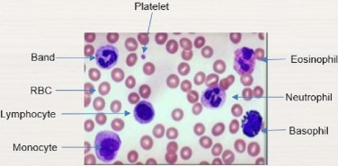
Figure (3): Normal peripheral blood smear ( Hegde et al., 2018).
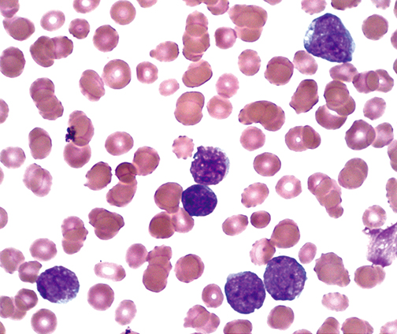
Figure (4): peripheral smear findings in ALL.
Large lymphoblasts with a prominent nucleoli and light blue rim of cytoplasm. Blast cells have more abundant cytoplastm and their nucleus is often fissured or indented (National Cancer Institute, 2013).
1.2.Blood chemistry and coagulation tests:
Blood chemistry tests measure the amounts of certain chemicals in the blood, but they are not used to diagnose leukemia. In patients already known to have ALL, these tests can help detect liver or kidney problems caused by spreading leukemia cells or the side effects of certain chemotherapy drugs. These tests also help determine if treatment is needed to correct low or high blood levels of certain minerals. Blood coagulation tests may also be done to make sure the blood is clotting properly
2-Bone marrow investigation:
The hallmark of the diagnosis of ALL is the blast cells, relatively undifferentiated cells with diffusely distributed nuclear chromatin, one or more nucleolei and basophilic cytoplasm. Bone marrow is usually replaced by 80- 100% blasts. Megakaryocytes are usually absent. Leukemia must be suspected when the bone marrow contains more than 5% blasts (Harb, 2010).
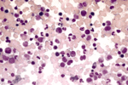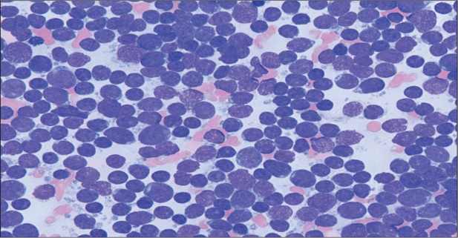
Figure (5): Normal marrow aspiration and ALL marrow aspiration
The image on the left shows normal bone marrow cells and a moderate number of lymphocytes (the purple-stained cells) distributed throughout the smear (Kersey, 1997). In ALL patient, as seen at right, lymphoblasts and undeveloped lymphocytes dominate and are present at unusually high concentrations (Warren et al., 2015).
3-Immunophenotyping:
A panel of monoclonal antibodies is used to differentiate ALL from acute myeloid leukemia (AML). A further panel of B-and T-lineage markers and lymphocyte maturation markers are used to sub classify ALL .

Table (3): Immunological classification of childhood acute lymphoblastic leukaemia (Provan, et al., 2004):

Immunological subgroup | Immunophenotypic profile
B lineage Pro B-ALL | HLA-DR+, TdT+, CD19+ (5% children; 11% adults)
Common ALL | HLA-DR+,TdT+,CD19+,CD10+ (65% children; 51% adult)
Pre B-ALL | HLA-DR+,TdT+,CD19+,CD10+,cytoplasmic IgM+
B-cell ALL | HLA-DR+,CD19+,CD10+,surface IgM+ (3% children; 4% adults).
T lineage Pre-T ALL | TdT+,cytoplasmic CD3+,CD7+ (1% children; 7% adults)
T-cell ALL | TdT+,cytoplasmic CD3+, CD1a/2/3+,CD5+ (11% children; 17% adults

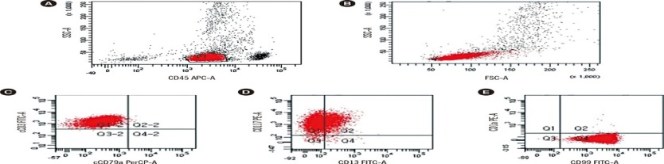
Figure (6): Immunophenotyping of early T-cell precursor-ALL bone marrow sample. (A) CD45/SSC dot plot with the blast population highlighted. (B) FSC/SSC plot of the sample. Blasts are positive for cCD3 (C); CD13, CD117 (D); CD99 (E) and negative for CD1a (Dongjin et al., 2016).
4-Chromosome testing:
Cytogenetics represents an important step in ALL classification. fluorescence in situ hybridization (FISH) can enable the detection and direct visualization of virtually all investigated chromosomal abnormalities in ALL, with a sensitivity of around 99%. Finally, array-comparative genomic hybridization (array-CGH, a-CGH) and single nucleotide polymorphisms (SNP) arrays can permit the identification of cryptic and/or submicroscopic changes in the genome. Karyotypic changes found in ALL include both numerical and structural alterations which have profound prognostic significance ( Kolomietz et al., 2001).5-Imaging tests ( NCCN, 2017):.

5.a. CT scan:

ACT scan of the head may be needed if there are symptoms that suggest ALL might have spread to brain and spinal cord. Occasionally leukemia may grow outside of the bone marrow - most commonly in lymph nodes. A CT scan of the head, neck, chest, abdomen, and/or pelvis can be used to look for leukemia in these places. In some cases, doctor may also perform a CT to look for infection.
5.b. Magnetic Resonance Imaging( MRI scan):
Magnetic Resonance Imaging uses radio waves and magnets to take pictures of the inside the body. MRI scans create clear pictures of soft tissues and bones. MRI scans are also very helpful for looking at the brain and spinal cord. An MRI scan of the head and/or spinal cord should be done if you there are symptoms that suggest ALL might have spread to the brain and spinal cord.
5.c. Positron Emission Tomography( PET scan):
PET (positron emission tomography) shows how the cells are using a simple form of sugar. For a PET scan, a sugar radiotracer will first be injected into the body. The radiotracer is detected by a special camera during the scan. Any cells that use sugar more quickly, including normal cells (such as those within the brain) and abnormal cells (such as leukemia), can be detected by this scan. PET scans are often combined with a CT scan to help your doctors better understand which areas of the body may be impacted by leukemia. Like standard CT imaging, PET/CT imaging is most helpful when doctors suspect there may be leukemia growing in places other than the bone marrow.

5.d. Echocardiogram or cardiac nuclear medicine scan:

This test is used to check how well the heart is by working by using sound waves to make pictures. It shows doctors how your heart is beating and pumping blood.. This test uses a radiotracer, just like a PET scan, to get detailed pictures. It can help doctors see how well your heart is able to pump blood. Some treatments for ALL can damage your heart. Thus, doctors may want to test how well your heart works in order to plan the best treatment.

Anti-leukemic agents

One of the hallmarks of the treatment of childhood ALL is the reliance on risk-based stratification. By identifying the features that have been shown to affect prognosis, patients can be classified into groups based on risk of treatment failure. Those with favorable features can be treated with less toxic regimens, whereas more aggressive regimens are reserved for those with more high-risk disease (Möricket al., 2005).

Risk categories (Pui et al., 2012).
- low-risk
  - Age greater than 1 and less than 10 years.
  - WBC less than 50,000 at diagnosis.
  - Hyperdiploid (DNA index greater than 1.16).
  - Must respond to treatment by having less than 5% bone marrow blasts at day 19 or 26
  - Must respond to treatment by having less than 0.01% MRD on day 46.
- standard-risk
  - Age 10 years or over.
  - WBC greater than 50,000 at diagnosis.
  - CNS involvement: greater than 5 wbc per microliter of CNS fluid.
  - Testicular leukemia.
  - Hypo diploid (less than 45 chromosomes).
  - T-cell.
  - T(1:19) and E2A-PBX1 fusion.
  - MLL rearrangement [often t(4;11)] .

High-risk features in pediatric acute lymphocytic leukemia (ALL) (Cooper and Brown, 2015) :

Age less than 1 year old or greater than 10 years old.

Initial white blood cell count greater than 50,000/μL.

Central nervous system involvement.

Testicular involvement.

Unfavorable cytogenetics (hypodiploidy, t(9;22), 11q23, iAMP21).

Suboptimal induction response (induction failure or positive minimum residual disease).

-Treatment strategies of ALL:

1-Treatment of newly diagnosed ALL:

A-Chemotherapy:
  - Induction Therapy :
Remission induction is the first block of chemotherapy, lasting 4 to 6 weeks. The goal of this therapy is to induce a complete remission by its completion, with approximately 95% of all patients achieving this benchmark (Schrappe et al., 2012).
The agents used during induction include vincristine, corticosteroids, and asparaginase, with most regimens adding an anthracycline (usually doxorubicin or daunorubicin). The corticosteroid used is usually prednisone or dexamethasone, with dexamethasone demonstrating improved CNS penetration and decreased risk of relapse (Escherich et al., 2013).
Evaluation of bone marrow MRD at the end of induction has proved to be an independent factor predicting outcome, and has also been shown to be useful in the peripheral blood as early as day 8 of therapy. End-induction MRD has been established in the risk stratification of Bp –ALL. This technique uses flow cytometry or the polymerase chain reaction (PCR) to assess for disease at a significantly lower limit of detection (1 leukemic blast in 10,000– 100,000 cells) (Borowitz et al., 2008).
Children in "complete remission” (CR) must have no physical evidence of leukemia, normal complete blood cell count and normally regenerating bone marrow (with < 5% leukemic blasts). Information on CR status also includes the absence of detectable CNS or extramedullary disease (Vrooman and Silverman, 2009).
  - Consolidation Therapy:
After induction therapy, subsequent consolidation therapy begins to eradicate residual leukemic cells lasting approximately 6 to 9 months. This phase of chemotherapy involves combinations of different chemotherapeutic agents to maximize synergy and minimize drug resistance, often including agents not used in the initial remission induction, such as mercaptopurine, thioguanine, methotrexate, cyclophosphamide, etoposide, and cytarabine (Seibel et al., 2008).
  - Maintainance therapy:
Maintenance chemotherapy is the final and longest stage of treatment in childhood ALL. The prolonged maintenance phase has been demonstrated to lower the risk of relapse once remission has been established. It usually lasts at least 2 years (extended to 3 years for boys) in some protocols. The maintenance therapy agents are antimetabolite therapy with methotrexate and mercaptopurine, both available in oral formulations, making strict adherence crucial (Bhatia et al., 2012).

Table ( 4 ): mechanism of action of anti leukemic agents (Sharma, 2009):
Generic name | Mechanism of action
Corticosteroids  (prednisone, dexamethasone) | Induction of apoptosis and/or cell cycle arrest (Kofler et al.,2003).
Doxorubicin | Drugs bind to DNA through intercalation between specific base pair thus block the DNA synthesis.
Vincristine | Arrest the cell division in metaphase by binding to tubulin.
Cyclophosphamide | Introduce alkyl groups into DNA and create cross linking between two DNA strands and inhibit protein synthesis
Etoposide | Inhibits topoisomerase II thus prevent resealing of DNA which leads to cell death.
Cytarabine | Block pyrimidine nucleotide formation by incorporation into newly synthesized DNA.
6-Mercaptopurine & Thioguanine | Act as fraud substrate for biochemical reactions and inhibit the synthetic steps during S-phase of replication.
L-Asparaginase | Asparagine depletion , inhibition of protein and RNA synthesis, induction of cell cycle arrest and apoptosis in murine leukemia cell lines (Appel,2008).

Table (5): Total Therapy Study XV for Newly Diagnosed Patients with Acute Lymphoblastic Leukemia (Pui et al., 2004):
Phase | Regemine
Remission Induction (6-7 weeks) | - cytarabine (ARA-C) intrathecally (IT) on day 1  - immediately following: high-dose (1g/m2) methotrexate IV randomization (with leucovorin rescue):  - 4 hour infusion OR  - 24 hour infusion  - day 4, begin:  - prednisone (days 5-32)  - vincristine (days 5, 12, 19, 26)  - daunorubicin (days 5, 12)  - asparaginase (days 6, 8, 10, 12, 14, 16 (19, 21, 23 depending on BMA result))  - TITs - mtx, hydrocortisone, ara C - day 19, also days 8 and 26 if CNS involvement (and high risk cases)  - cyclophosphamide (day 26)  - ara C (days 27-30, 34-37)  - 6MP (days 26-39)
BMAs done:
- day 19; if greater than 5% blasts, add asp days 19, 21, 23
- day 26 done if any blasts at all were seen on day 19
- day 43 to 46 - remission-induction BMA, when ANC is greater than 300. MRD is done.
  - poor-response is when MRD is greater than 0.01%
    - if the patient was low- or standard-risk before this, they now become (or remain) standard risk if MRD is 0.01-1%
    - what ever the previous risk, if MRD is greater than or equal to 1%, they become high risk
  - induction failure is when the value is greater than 1% leukemic cells in the bone marrow

Consolidation (8 weeks) |  | - high-dose MTX (HDMTX), days 1, 15, 29, 43 (IV with leucovorin rescue, 24 hour infusion)  - dose depends on risk classification and on each patient's estimated systemic clearance (5 gm/m2 for standard and high risk, 2.5 g/m2 for low risk)  - 6MP every day for 8 weeks  - ITs days 1, 8, 15
Reintensification Treatment |  | (only for high-risk patients)  Patients are re-intensified with dexamethasone, ara C, etoposide, L-asp, and TITs over a 6 week period, and then offered the option of BMT; the reintensification is sometimes repeated. Some patients do not have a BMT and continue on the therapy outlined below.
Continuation (120 weeks for girls and 146 weeks for boys) |  | weeks 1-6 and 10-16  - dexamethasone, doxorubicin, vincristine, 6 MP, and L-asp weeks 1 and 4: doses differ for different risk groups  - 6 MP and L-asp weeks 2, 3, 5, 6.  weeks 7-9, 17-20 re-induction  - dexamethasone, vincristine, doxorubicin, L-asp, TITs, ara C: doses and schedules differ for different risk groups  weeks 21 to end of therapy  - low risk: 6 MP (daily), MTX (weekly), dexamethasone and vincristine (every 4 weeks)  - standard and high risk: 6 MP, MTX, dexamethasone and vincristine (every 4 weeks), cyclophosphamide and ara C (every 4 weeks)  - TITs vary for different risk groups

2-Clinical advances in specific subtypes of ALL:
Chromosomal translocation of chromosomes 9 and 22, known as the Philadelphia chromosome and resulting in the fusion product BCR-ABL, occurs in approximately 3% of childhood ALL. Although these patients are classified as high risk, the introduction of imatinib, a tyrosine kinase inhibitor that targets the BCR-ABL fusion protein, has markedly improved the outcome of this disease. Newer generations of tyrosine kinase inhibitors (such as dasatinib, nilotinib, and ponatinib) have been recently introduced with evidence of improved efficacy in adults (Schultz et al., 2009).
In cases with MLL rearrangement, the leukemic cells typically express high levels of FLT3, a tyrosine kinase oncogene; therefore, studies are proceeding to test the addition of a FLT3 inhibitor to conventional chemotherapy regimens. Also, these patients have a high risk of treatment-related mortality, and thus induction often includes a 1-week prophase of single-agent steroid to “debulk” the initial leukemic burden before initiation of multi-agent chemotherapy. Similar to MRD evaluation, response to this steroid prophase has been shown to correlate with risk of treatment failure (Pieters et al., 2007).
Patients with T-cell ALL nearly represents 10% of pediatric ALL .In comparison with those with Bp-ALL, T-ALL patients continue to experience a lower risk of survival after relapse. With more aggressive modern regimens, many patients with T-ALL have survival approaching that of Bp-ALL. Studies are currently ongoing regarding the addition of nelarabine, a purine nucleoside analogue that appears to be particularly cytotoxic to T cells, with promising results in the relapsed setting (Berg et al. 2005).

The use of allogeneic hematopoietic stem cell transplant (HSCT) in first remission of ALL is a controversial topic. In general , HSCT is considered for those patients with the very highest risk of relapse and/or treatment failure, which has been most closely associated with those patients demonstrating hypodiploidy or induction failure. T-cell immunophenotype, prognosis is worse, and HSCT is often pursued. With intensive therapy that may include HSCT, overall survival from relapsed ALL is almost 40%37.The optimal donor has historically been a matched sibling, although advances with alternative donor sources are now also showing promise (Hochberg et al., 2013).
3-Treatment of relapsed ALL:
In spite of significant advances in treatment, nearly 15% to 20% of patients with ALL will suffer relapsed disease. Length of first complete remission (CR1) and site of relapse have consistently been demonstrated to be the 2 most important prognostic factors in these cases. For patients with Bp-ALL, relapses within 18 months of diagnosis fare the worst, those occurring between 18 and 36 months after diagnosis have an intermediate prognosis, and late relapses that occur more than 3 years from diagnosis have the best prognosis, with up to a 50% event-free survival (Chessells, 1998).
Reinduction chemotherapy after first relapse is successful at inducing complete remission in 65% to 85%. The chemotherapy regimens used vary by institution and protocol, but is often the same 4-drug induction used at initial diagnosis, consisting of vincristine, steroids, asparaginase, and an anthracycline. Clinical trials are proceeding to evaluate the addition of novel agents for reinduction chemotherapy. Once a second complete remission (CR2) has been obtained, postremission treatment varies by risk ( Parker et al. 2009).
For those isolated CNS Bp-ALL relapses occurring more than 18 months from diagnosis, survival rates of 70% can be achieved with chemo radiation. Treatment of isolated testicular relapse also depends on duration of CR1, with worse outcomes for those patients experiencing an isolated testicular relapse while still receiving upfront therapy. Therapy for testicular relapse usually consists of intensive reinduction chemotherapy (often including high-dose methotrexate) followed by testicular radiation or orchiectomy if complete remission is not achieved (Cooper and Brown, 2015).
4- Novel Agents in the treatment of (ALL):
Immunotherapy is a broad and promising field that seeks to harness the power of the immune system to allow for a more targeted approach. Chimeric antigen receptors are one example of modified adoptive cell transfer whereby the patient’s own cytotoxic T cells are genetically engineered to express an antibody to target leukemic antigens (often CD19), often enhanced by the inclusion of costimulatory binding regions that allow for improved cytotoxicity and duration of cells (Brentjens and Curran 2012). Another example of immunotherapy is blinatumomab, a bispecific anti-CD19/CD3 molecule, which enforce cytotoxic killing by binding both a protein expressed on the leukemic blast (CD19) and one expressed on autologous T cells (CD3) (Hoffman and Gore,2014).

Influence of TPMT genetic polymorphism on 6-MP related toxicity during maintenance therapy of ALL
In the induction phase, chemotherapeutic agents including vincristine, anthracyclines, corticosteroids and asparaginase are used to immediately kill off leukemic cells. High toxicity and substantial side effects are reported for these drugs. In the consolidation phase, these drugs are used together to maximize synergy. Although the drugs used in these first two stages are relatively toxic, these phases of the treatment usually last for several weeks to several months only (Cooper and Brown , 2015).
6-mercaptopurine (6-MP) and methotrexate (MTX) are the drugs commonly used during maintenance therapy, they are used consistently and investigated extensively as well. The maintenance phase is far longer, lasting approximately 2–3 years in pediatric patients. Ideally, chemotherapeutic agents used for so long a period of time should have minimal side effects, or low severe side effects . However, this is not the case for 6-MP and MTX, since both of them have potentially serious and life-threatening toxicities that can occur in a subset of patients (Paugh et al., 2010).
Survival rates for pediatric ALL have improved substantially in recently ; however, the ultimate goal in ALL treatment is to have the best survival outcomes with the least toxicity. As such, treatment regimens are typically designed aiming to minimize toxicity for the patient while maximizing survival (Rudin et al., 2017).

Table (6): Adverse effects of common chemotherapeutic agents used in the treatment of ALL:
Agent | Effects
Asparaginase | Hypersensitivity reactions, pancreatitis, thrombosis
Clofarabine | Cardiotoxicity, cytokine release syndrome, hepatotoxicity (including sinusoidal obstruction syndrome), pancreatitis, nephrotoxicity
Corticosteroids | Hypertension, hyperglycemia, osteonecrosis, fluid retention, psychosis
Cyclophosphamide | Nephrotoxicity, hemorrhagic cystitis, hyponatremia, fluid retention
Cytarabine | Conjunctivitis, flu-like symptoms
Doxorubicin/daunorubicin | Cardiotoxicity, benign red urine
Etoposide | Nephrotoxicity, hepatotoxicity, hypersensitivity reactions
Mercaptopurine | Hepatotoxicity
Methotrexate | Mucositis, nephrotoxicity, hepatotoxicity, encephalopathy
Thioguanine | Hepatotoxicity (including sinusoidal obstruction syndrome and portal hypertension)
Vincristine | Syndrome of inappropriate diuretic hormone, neuropathy (foot/wrist drop, paresthesias, constipation, ptosis, vocal cord paresis)

Table (7): Classification of hepatotoxicity according to NCI-CTC v2.0 (Beaumais et al., 2010).
Adverse Event grades | 0 | 1 | 2 | 3 | 4
Hepatic
Alkaline phosphatase | WNL | >ULN – 2.5 xULN | >2.5–5.0 xULN | >5.0–20.0 x ULN | >20.0 x ULN
Bilirubin | WNL | >ULN – 1.5 x ULN | >1.5–3.0 x ULN | >3.0–10.0 x ULN | >10.0 x ULN
GGT (g-glutamyl transpeptidase) | WNL | >ULN – 2.5 x ULN | >2.5–5.0 xULN | >5.0–20.0 x ULN | >20.0 x ULN
Hepatic enlargement | absent | absent | absent | present | present
Hypoalbuminae-mia | WNL
Liver dysfunction/failure (clinical) | Normal | Normal | Normal | Asterixis | Encephalopathy or coma
Portal vein flow | Normal | Normal | Decreased portal vein flow | Reversal/retrograde portal vein flow
SGOT (AST) | WNL | >ULN – 2.5x ULN | >2.5–5.0 x ULN | >5.0–20.0 x ULN | >20.0 x ULN
SGPT | WNL | >ULN – 2.5x ULN | >2.5–5.0 x ULN | >5.0–20.0 x ULN | >20.0 x ULN
Hepatic – Other (Specify,_________) | None | Mild | Moderate | Severe | Life-threatening or disabling
1-Thiopurine S-methyltransferase (TPMT):
Thiopurine S-methyltransferase (TPMT) is an important cytoplasmic enzyme that catalyses the rate-limiting step in the metabolism of thiopurine drugs. It is coded by the TPMT gene and exerts its effect via S-adenosyl-L-methionine as the S-methyl donor and S-adenosyl-L-homocysteine as a by-product. Thiopurine drugs, mainly 6-mercaptopurine (6-MP), and its prodrug azathioprine (AZA), are implicated as antimetabolite cytotoxic and immunosuppressive agents in the treatment of malignancies such as acute lymphoblastic leukemia (A LL) (Kotur et al., 2015).
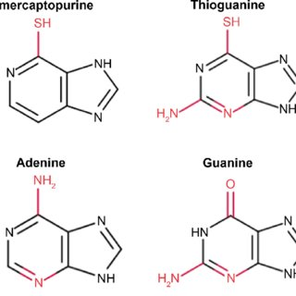
Figure (7): Structures of 6-MP and thioguanine (Zhou et al., 2006).

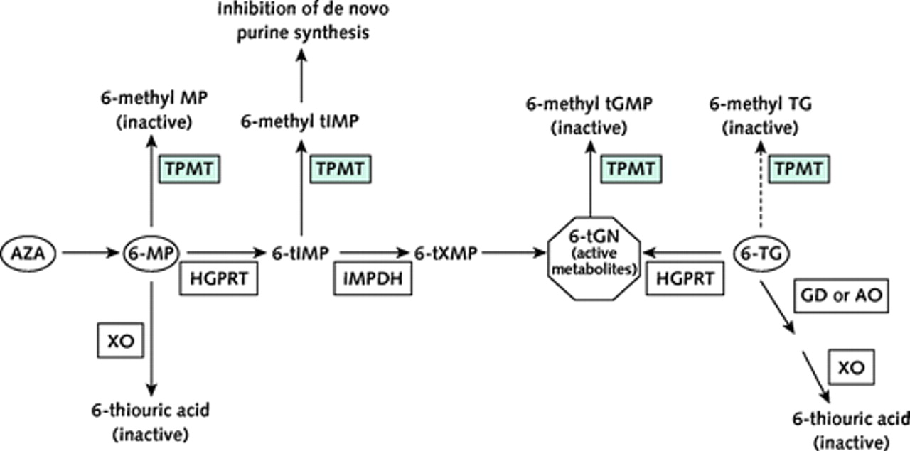
Figure (8): Metabolization of thiopurine-based drugs ((Ronald et al., 2011).
Azathioprine is converted to 6-mercaptopurine and S-methyl-4-nitro5-thioimidazole in the plasma and tissue by the sulfhydryl-containing compounds (glutathione-dependent process). The S-methyl4-nitro-5-thioimidazole is inactive and represents the first stage of drug elimination and inactivation. The 6-mercaptopurine is metabolized by several enzymatic routes (Arnott et al., 2003).
One route metabolizes it by thiopurine methyltransferase (TPMT) to methyl-thiopurine metabolites, which are inactive. The other metabolic routes—hypoxanthine phosphoribosyl transferase (HGPRT), inosine monophosphate dehydrogenase (IMPD), and guanine monophosphate synthetase (GMPS)— produce active thiopurine nucleotides (eg, 6-methyl-mercaptopurine, 6- methyl-thioinosine-5'-monophosphate and 6-thioguanine nucleotides), and xanthine oxidase (XO) produces the inactive 6-thiouric acid (Higgs et al.,2010).

6-TGNs then either incorporate directly into DNA, which triggers delayed cytotoxicity, or they inhibit intracellular signaling pathways that ultimately promote cell death via apoptosis. Furthermore, 6-MP is also metabolized to methyl-thioinosine-monophosphate that provokes an additional cytotoxic effect by inhibiting de novo purine synthesis (Wang et al., 2010).
Thioguanine (TG) is also a prodrug that belongs to the thiopurines family (2-amino-6-mercaptopurine) and is also partly metabolized by TPMT. Like AZA and 6-MP, it exerts its effect through mechanisms that involve the production of 6-TGNs, but have different pathways. However, due to its more pronounced toxicity profile and lack of additional benefit, its use became somewhat restricted to the intensification phase of some antileukemia protocols (Vora et al. 2006).
2- Influence of TPMT genetic variant on 6-MP therapy:
It is well established that the balance between 6-TGN and 6-MMPN is highly variable and primarily influenced by genetic polymorphisms of TPMT (Cheok and Evans , 2006).
Genetic polymorphisms in the TPMT gene can affect the enzymatic activity of TPMT and have been studied extensively. To date, over 38 variant alleles have been identified. They have been assosciated with variability in response to thiopurine drugs, which provides an important example of the clinical importance of pharmacogenetics (Katara and Kuntal , 2016).

Patients with absent or reduced TPMT activity accumulate high doses of 6-TGNs, resulting in thiopurine-induced myelotoxicity that is characterized by early onset of severe neutropenia when such patients are treated with standard doses of thiopurine drugs. This toxicity is particularly evident in patients carrying two nonfunctional alleles and requires treatment cessation or dose adjustment (Higgs et al., 2010).
The wild-type allele is known as TPMT*1. The mutant TPMT*2 allele is defined by the G238C transversion whereas the TPMT*3 family alleles are defined by the G460A and A719G transitions (i.e., TPMT*3A[G460A and A719G], TPMT*3B[G460A] and TPMT*3C[A719G]) ( Lennard et al., 2015).
Across all ethnic groups, ~1 in 300 individuals are homozygous for a mutant TPMT allele and have very low or absent TPMT activity while around 4%–11% of individuals are heterozygous and are generally considered to have intermediate enzymatic activity ( Schmiegelow et al.,2009) .
The prevalence of TPMT variants is much higher among Caucasians (8.1%–10.1%) than Asian populations (2.3%–4.2%) and it is well established that TPMT*3A is the most prevalent mutant allele in Caucasians, making up to (85%) of all observed mutant alleles, while TPMT*3C is the most frequently found allele in African and Southeast Asian populations (Liu et al., 2015).

There are many factors influence TPMT enzyme activity such as the age and gender of the patient, concomitant administration of drugs that may interfere with the disease condition or TPMT activity (e.g., methotrexate), levels of TPMT cofactor S-adenosyl-methionine, recent blood transfusion, life span of red blood cells, as well as untested rare or novel variants in the coding and regulatory regions of the TPMT gene (e.g., TPMT*38 and the VNTR architecture) ( Tamm et al., 2016).
3-Methods of detection of TPMT:
It is mandatory to generate an efficient diagnostic tool for the determination of TPMT*2 and *3 alleles, as well as other different allels. Recently few studies describe modern methods for TPMT alleles determination using real-time polymerase chain reaction (PCR) machines have been presented, such as using multiplex high resolution melting (HRM) analysis for identifying TPMT*2, TPMT*3A, TPMT*3C (Lorenz et al.,2012).
Molecular analysis for the most common TPMT mutations: TPMT*2 (G238C), TPMT*3A (G460A, A719G), TPMT*3B (G460A) and TPMT*3C (A719G) was carried out by PCR and restriction fragment length polymorphism ( R F L P ) . Briefly, DNA was extracted from peripheral blood and directly used in PCR, after measuring concentration on ananodrop spectrophotometer (Thermofisher) at 260 nm, for assessing adequacy. The amplified PCR product was digested by polymorphism specific restriction enzymes and suitable buffer Restriction enzymes used were MwoI, and AccI for TPMT*3B and TPMT*3C respectively. Digestion products were electrophoresed on 2%. On the basis of different sized fragments generated, patients were divided into wild type, homozygous or heterozygous mutants (Raju et al., 2010).
The previous standard methods for mutation detection (RFLP) is accused by being time-consuming, laborious and expensive. As a result, new high-throughput molecular genetic techniques has been developed to replace it (Burchard et al.2014).
Further validation of results is done by reverse dot blot method, using Vienna Lab PGX-TPMT Strip Assay® kit (Austria). The procedure for Reverse dot blot analysis included steps (Ambar et al., 2018).:
(1) PCR amplification using biotinylated primers.
(2) Hybridization of amplification products to a test Strip containing allel - specific oligonucleotide probes immobilized, as an array of parallel lines.
(3) Bound biotinylated sequences detected using streptavidin-alkaline phosphatase (Conjugate) and color substrates. If the reaction comes positive, a purple staining would appear. Genotype was determined by comparing the test strip, with the comparison strip given by the manufacturer along with kit. This assay covered the three most common polymorphic loci.
4-Dose adjustment of thiopurine drugs concerning TPMT genetic polymorphism:
1-The Clinical Pharmacogenomics Implementation Consortium (CPIC) guidelines (Relling et al., 2011):
Heterozygous TPMT genotype (intermediate activity): In patients who possess a single TPMT functional (*1) and nonfunctional allele (*2, *3A, *3B, *3C, or *4), the initial dose of AZA or 6-MP should be reduced by 30-70%. The AZA dose can be titrated as tolerated. The 6-MP dose should be adjusted based on the severity of myelosuppression and disease-specific guidelines. The initial dose of TG should be reduced by 30-50%, and adjusted based on the severity of myelosuppression and disease-specific guidelines. While, homozygous TPMT genotype (variant mutant, low, or deficient activity): Reduce the initial dose of AZA, 6-MP or TG by 10-fold and extend the dosing frequency from daily to three times weekly, or select an alternative drug.
2-The Royal Dutch Association for the Advancement of Pharmacy Pharmacogenomic Working Group (Swen et al., 2011):
Patients who are intermediate metabolizers based on the TPMT genotype or phenotype test: The dose of AZA or 6-MP should be reduced by 50% and titrated based on hematologic monitoring and efficacy, or select an alternative drug. Patients who are poor metabolizers based on the TPMT genotype or phenotype test: The dose of AZA or 6-MP should be reduced by 90% and titrated based on hematologic monitoring and efficacy, or select an alternative drug. Patients who are intermediate or poor metabolizers should not be treated with TG as there are “insufficient data to allow calculation of dose adjustment.”
5-Pharmaco genetic consideration of 6- MP:
Actually TPMT is not the only gene that may affect 6-MP toxicity. Other genes, in particular, PACSIN2, MRP4, ITPA have also been investigated.
PACSIN2 encodes the protein kinase c and casein kinase substrate in neurons 2, which plays a role in intracellular vesicle-mediated transportation and caveolae formation. PACSIN2 is thought to be associated with TPMT activity and its effects on 6-MP. Analysis initially identified PACSIN2 polymorphisms, especially rs2413739 (NC_000022. 10:g.43397036C>T), as a significant determinant of TPMT activity, which was later supported by clinical trials (Stocco et al., 2012).
The multidrug resistance protein 4 (MRP4) belongs to the ATPbinding cassette transporter superfamily. MRP4 is primarily involved in the efflux of nucleoside derivatives and has a role in the determination of drug sensitivity. It has the ability to transport anticancer drugs such as thiopurines and MTX, and is expressed in various blood cells and several tissues such as the prostate, liver, testis, ovary, kidney, brain and adrenal gland (Ritter et al., 2005).
Cells expressing MRP4 are resistant to thiopurine-induced myelotoxicity because of their ability to export 6-thioguanine nucleotides from the cells. On the other hand, MTX accumulates in the cells with low expression levels of MRP4. Therefore, we hypothesized that MRP4 genotype was related to therapeutic effect in maintenance therapy for ALL. In Japanese population, the frequency of missense variants in MRP4 G2269A, C912A and G559T, located in the coding region of MRP4 (Krishnamurthy et al.,2008).
The genetic polymorphism of MRP4 C912A changed the expression amount of MRP4 in liver of patients with variant alell. The genetic variant of MRP4 G2269A also induces a lower expression of MRP4 protein, and the bone marrow cells expressing lower level of MRP4 protein display enhanced 6-MP sensitivity (Gradhand et al., 2008).

In Japanese population, the frequency of missense variants in MRP4 G2269A, C912A and G559T, located in the coding region of MRP4, are 0.19, 0.30 and 0.14, respectively, which are relatively higher than that in Caucasian population (0.01, 0.02 and 0, respectively) (Tanaka et al., 2015).
ITPA is another enzyme involved in 6-MP metabolism. This enzyme catalyzes the hydrolysis of inosine triphosphate (ITP) to inosine monophosphate (IMP), protecting cells from the accumulation of harmful nucleotides such as ITP and deoxyinosine triphosphate. A C198A transversion (rs1127354) causing a Proline to Threonine replacement at codon 32 (P32T polymorphism) is the most relevant SNP determining low ITPA enzymatic activity (Stocco et al., 2009).
The distribution of P32T polymorphism varies from 1% to 15%. Recent studied found that the prevalence of ITPA was 1% in ALL patients and did not notice any differences in 6-MP toxicity or dosage in patients carrying the P32T polymorphism compared to wild type patients. A situation might be explained by the low the prevalence for ITPA found in this study. A recent study supports the importance of this polymorphism when 6-MP dosages had been adjusted for TPMT genotype (Stocco et al., 2010).

Pediatric Acute Lymphoblastic Leukemia: From Diagnosis to Prognosis

1-Vardiman JW, Thiele J, Arber DA, et al The 2008 revision of the World Health Organization (WHO) classification of myeloid neoplasms and acute leukemia: rationale and important changes. Blood 2009;114:937-951
2-zwerdling T (2017) Pediatric Acute Lymphoblastic Leukemia. Hematol Transfus Int J 5(3): 00118. DOI: 10.15406/htij.2017.05.00118.

